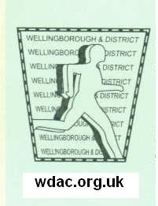

WELLINGBOROUGH 5 MILE ROAD RACE

NOW WITH CHIP TIMING START AND FINISH

SUNDAY 26th JULY 2015 – **10.30 am**

OLD GRAMMARIANS SPORTS FIELD SYWELL ROAD WELLINGBOROUGH NN8 6BS

Part of the Northamptonshire Road Race League

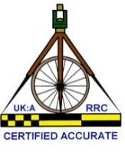

Permit applied for

WELLINGBOROUGH & DISTRICT AC

PLEASE COMPLETE IN BLOCK CAPITALS. Closing date for postal entries Tuesday 21st July 2015

Surname____________________________ Gender___________________ D.O.B__________________

Forename___________________________ Club________________________________________________

England Athletics Registration Number ______________________________________________

Address___________________________________________________________________________________

Postcode____________________________________ Age on 26/07/2014__________________________

Best Contact Number / e-mail address___________________________________________________________

Please enter me for the race. I agree to run under U.K.A rules and I accept that the race director’s decision is final. I accept that the organisers shall not be liable for accidents, loss or damage as a consequence of my participation in the event.

Signature________________________________ Date__________ Fee enclosed £_____ (£2 extra on day)

**Postal entries: No S.A.E required,(collect number on day) to: Race Director, Graham Bayes, 43 Holmes Avenue, WELLINGBOROUGH, Northants NN9 6SZ.**

**Please make cheques payable to ‘WDAC’**

In event of the race having to be cancelled through no fault of our own every effort will be made to refund entry fees minus our unavoidable costs

**Sponsored by:**



**Matthew Nicholas Estate Agents**

**IN ASSOCIATION WITH**:

Black Sheep Sports and Go Beyond

Individual Prizes:

1st three in all categories

Senior men, vet 40, 50 & 60

Senior female, vet 35, 45 & 55

**Winners will be given the trophy for the age category in which they run.**

Affiliated Team prizes:

1st & 2nd teams

Males team of 4 adding finishing positions

Females team of 3 as above.

**2015 CHARITY:**



**Race fee affiliated £12, unaffiliated £14**

Entries through **wdac.org.uk**

Entries available on the day until 10am

Race entry limit 400, minimum age 15 on the day

**\*Approx 1 mile fun run for under 15s within the sports field grounds at 10am, entry on day (fee £2)\***

**\*Toddlers dash\***

Course officially measured/ Race permit obtained.

Parking / Course marshalled / First aid cover

Ample changing facilities with showers

Start Sywell Road Wellingborough – 10 minute walk from Race HQ / Finish on the sports field

Mildly undulating fast course on country roads

**Cake and tea stall and licensed bar**

**Goody bag and Technical T shirt**