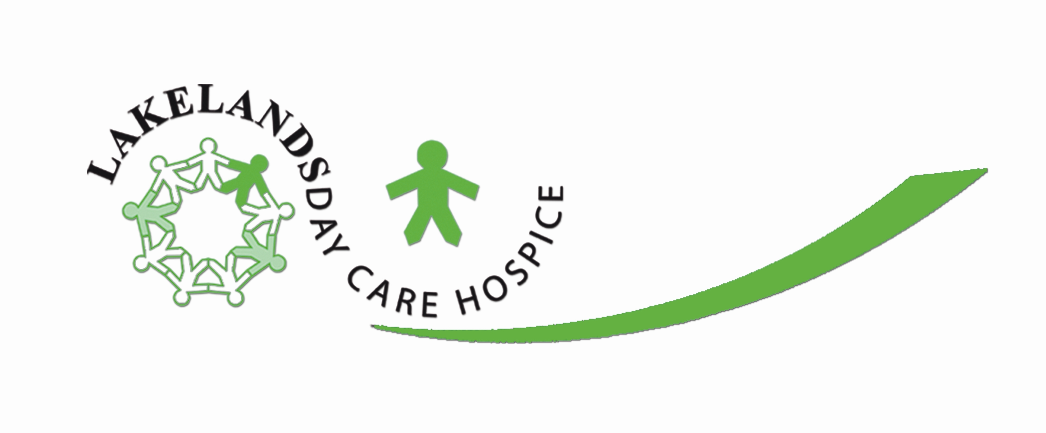
Butland Road · Oakley Vale · Corby
Northamptonshire · NN18 8LX

Telephone 01536 747755 · Facsimile 01536 747788
Web · www.lakelandshospice.org.uk
CORBY AND DISTRICT CANCER CARE
Company Limited by Guarantee
Company Number 3325051
Charity Number 1062120

Patrons
Fiona Castle O.B.E.
Sir Richard George C.V.O.
Cdr L.M.M. Saunders Watson C.B.E F.S.A. D.L.

Mr Tony Hale
Wellingborough And District Athletics Club

30th October 2012

Dear Tony

On behalf of everyone here at Lakelands Hospice I would like to thank you for the kind donation of £650.00 raised by the athletics club and its members throughout the year, it’s a wonderful gesture and is very much appreciated by everyone concerned.

Lakelands Hospice provides care for those with cancer-related illnesses and individuals affected by advanced heart failure. The hospice is developing constantly to the needs and demands of the local community. We have introduced our Hospice at Home Care Service and now need to raise in excess of £475.000. We do not receive any government funding and rely totally on charitable donations and fundraising events.

On behalf of patients, their carers and families who will benefit, thank you once again for your generosity and commitment to Lakelands.

Yours sincerely

Paul Marlow
Community Fundraising
Lakelands Hospice

Tel. 01536 747755
Email: paulmarlow@lakelandsdaycarehospice.org.uk

Follow Lakelands Hospice on Facebook

Follow Lakelands Hospice on Twitter - /LakelandsCorby

